# Unit 2

# Chapter 3: Unlocking the Atom

# Lesson 3: Isotopes and Atomic Variations

## <H1> Essential Question

How do isotopes affect the atomic mass of an element?

## <H1> Big Idea

Isotopes are atoms of the same element with differing neutron numbers, resulting in variations in atomic mass and unique properties, important for applications like carbon dating.

# <H1> Lesson Objectives

By the end of the lesson, I will be able to:

* define the term isotope and give examples of isotopes for a given element
* calculate the atomic mass of an element based on the abundance of its isotopes
* analyze the properties of different isotopes and explain their uses

## <H1> Curiosity Corner

Water is made up of hydrogen and oxygen atoms, but not every hydrogen or oxygen atom is the same. Some atoms of the same element have different numbers of neutrons, which makes them "isotopes." In this lesson, we’ll explore what makes certain isotopes stable while others are radioactive, and we’ll see how scientists use these atomic variations in real-life applications—like tracking isotopes to help manage resources or to keep roads safe during winter.

# <H1> Key Vocabulary

Isotope - Atoms of the same elements having the same atomic number but different mass numbers isotopes are atoms of the same element that have the same number of protons (atomic number) but different numbers of neutrons, resulting in different mass numbers

Relative abundance - The percentage of each isotope in nature. the percentage of a specific isotope of an element found in a natural sample compared to all isotopes of that element

## <H2> Ignite: Use AI Tools to Generate Questions

Enter the following prompts in an AI tool. You will obtain some information, which may not be reliable (you would need to verify with more reliable sources of scientific information if desired). However, the AI tool can give inspire you to formulate scientific questions. After entering the following prompts in an AI tool, write two to three questions related to each prompt and share your questions with classmates.

* Explain how atoms of the same element can vary.
* Elaborate the applications of isotopes in the real world.

## <H1> Direct Instruction: What’s Up with Neutrons?

**Recall** from the previous lesson that the number of unit positive charges, or protons, carried by the nucleus of an atom is called the atomic number. The sum of the numbers of protons and neutrons is known as the mass number. For example, the sodium atom in the figure below has an atomic number of 11 and a mass number of 23, meaning that it has 11 protons and 12 neutrons in its nucleus.

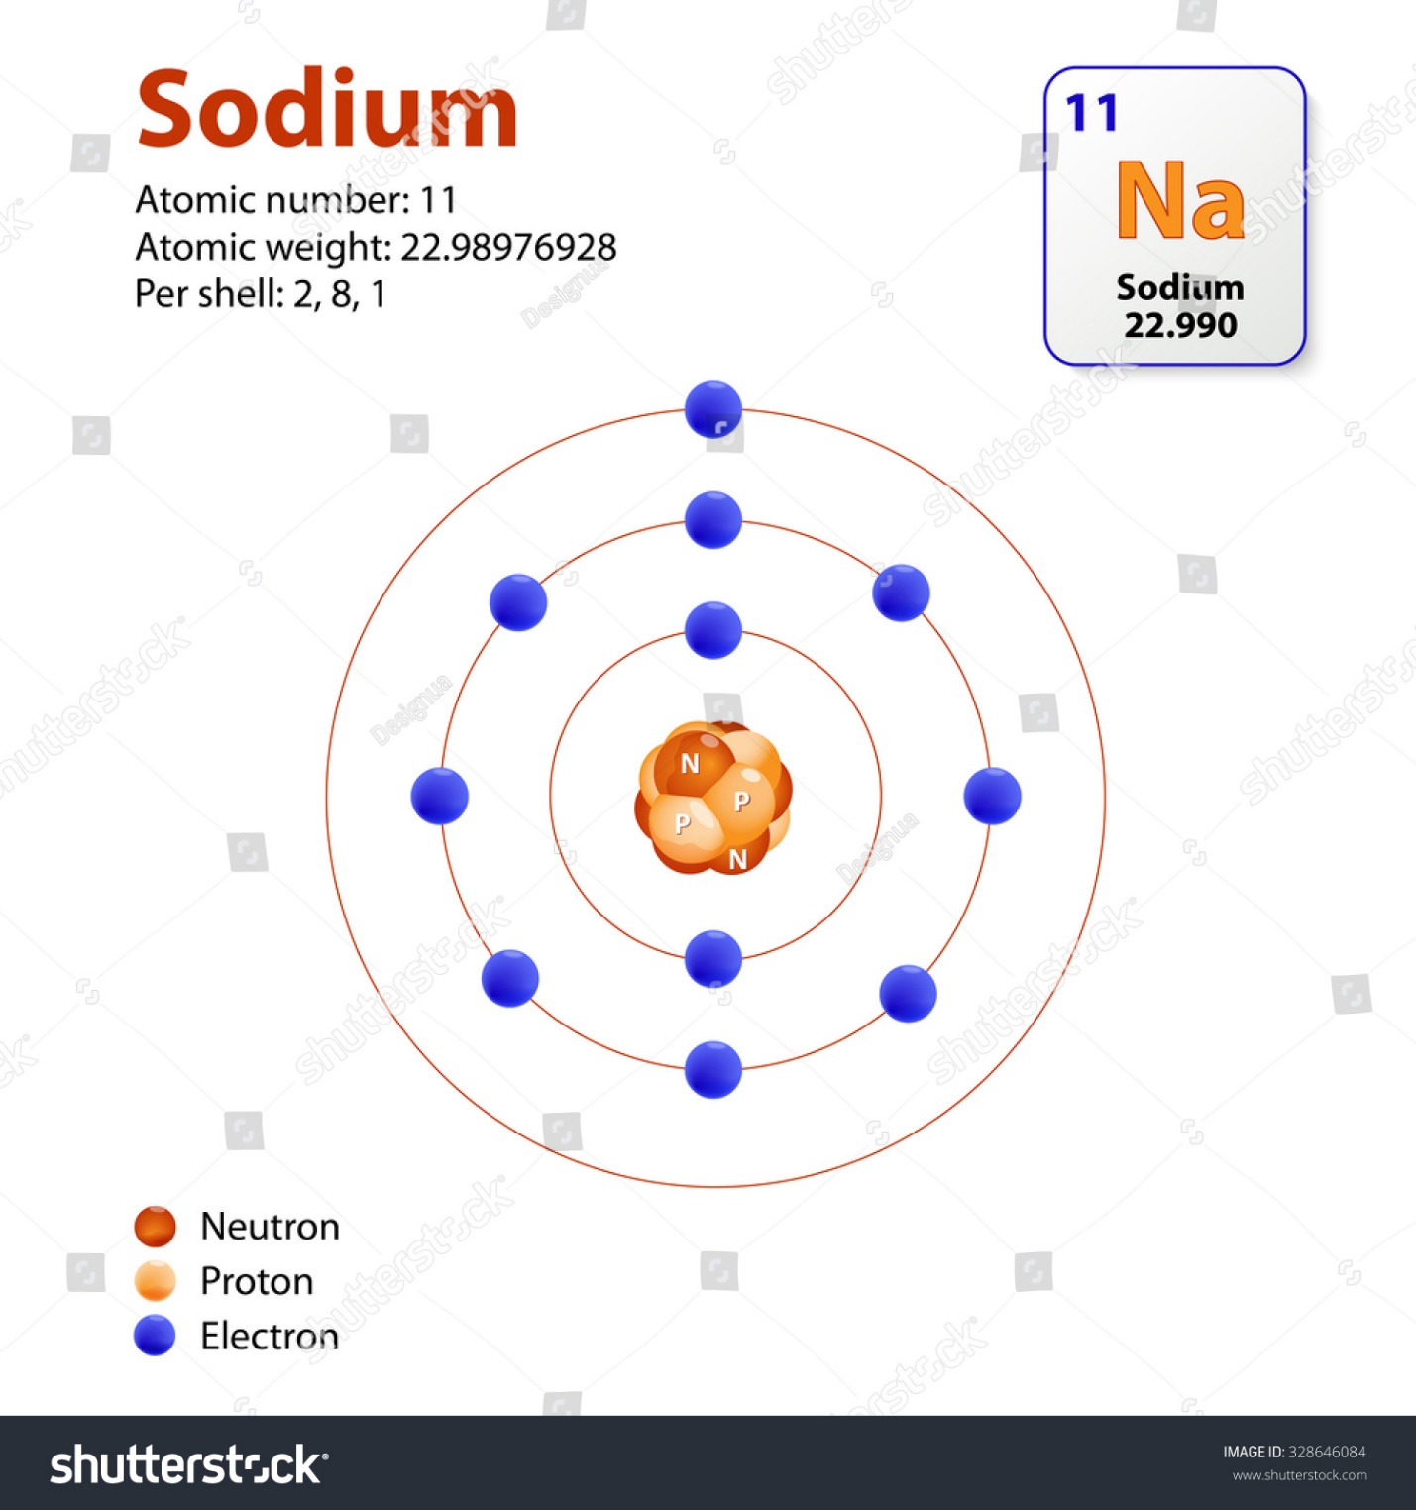

Figure 3.17. A sodium atom

So, the number of protons identifies the element. Electrons are present in the atom because their negative electrical charge is attracted to the positive electrical charge of the nucleus. To make the atom neutral or charged, depending on the number of electrons as compared to the number of protons. But what about neutrons?

It turns out that neutrons are present in atoms because they counteract the repulsive forces between protons and without them, an atom would not be stable, matter would not exist. But not all atoms of the same element have the same number of neutrons. For example, the nuclei of hydrogen atoms come in three kinds:

* one with no neutrons, called protium (H). It has only one proton in its nucleus): 11H
* one with one neutron, called deuterium (D). It still has only one proton (because it is hydrogen) but it has one neutron in its nucleus: 21H
* one with two neutrons, called tritium (T). It still has only one proton (because it is hydrogen) but it has two neutrons in its nucleus 31H

## <H2> Progress Check 1

1. Compare the number of subatomic particles in hydrogen (H), deuterium (D), and tritium (T).
2. Calculate their atomic number and mass numbers.

# <H1> Pathfinder: Exploring Isotopes

Go to <https://phet.colorado.edu/en/simulations/isotopes-and-atomic-mass> and build isotopes for the atoms that appear on the simulation.

**Observations and Discussion:**

* Observe how the choice of the number of neutrons affects the mass of the atoms (use mass number and amu).
* Explore the abundance in nature of each type of atom.
* Discuss with classmates how these atoms show physical differences, such as weight, based on their structure.

## <H2> Progress Check 2

What are the differences between atoms of the same element with different masses?

# <H1> Lightbulb: **What are These Atomic Species Called?**

These different kinds of atoms of the same element are called **isotopes**. Hydrogen has three isotopes: protium (11H), deuterium (12H or D), and tritium (13H or T). Almost all atom types have isotopes, but some isotopes are more abundant in nature than others. While isotopes of an element exhibit similar chemical properties because they have the same number of protons and electrons, some physical properties differ because of the different numbers of neutrons. 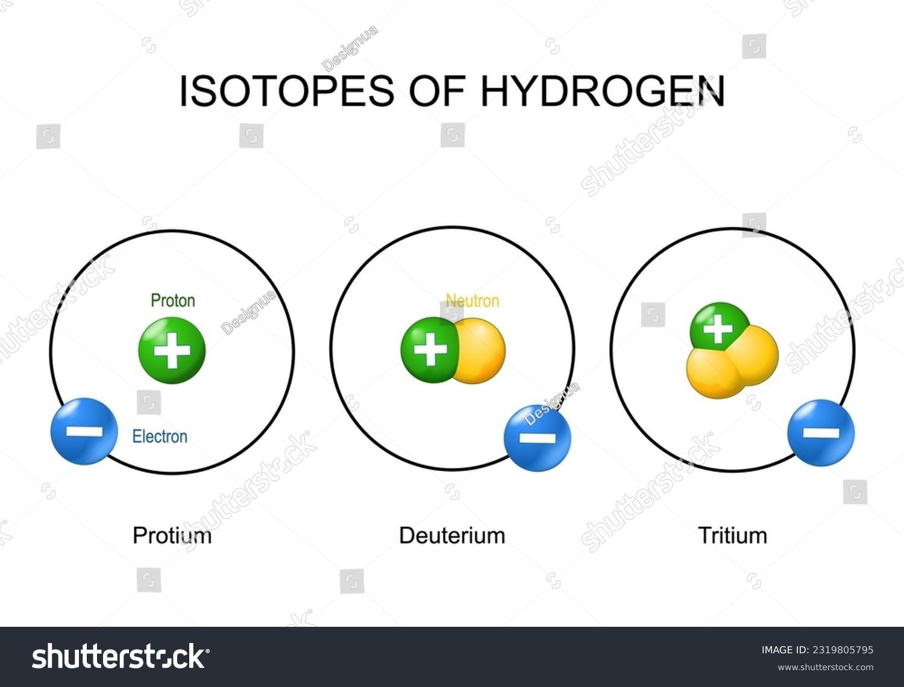

Figure 3.18. Three atomic species of hydrogen

## <H2> Progress Check 3

A molecule of water is made of two protium and one oxygen atoms. Another molecule of water is made of -two 21H or D and one oxygen atoms. How are these molecules different or the same?

# **<H1> Relative Abundance and Calculation of Atomic Mass**

Chlorine has two isotopes: chlorine-35 and chlorine-37. About 75% of the chlorine in nature is chlorine-35, while 25% is chlorine-37. This difference in isotopic composition leads to the concept of **relative abundance**, which refers to the percentage of each isotope in nature. But how do you calculate the average mass of chlorine atoms when there are isotopes? This is done by pondering the relative abundance of each isotope. The formula is: This is calculated using the relative abundance of each isotope and their respective mass numbers. The formula is:

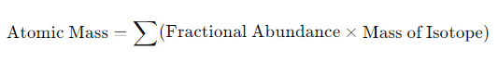

**So, the average atomic mass will be**

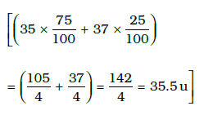

**In turn, the average atomic mass can be used to identify the most common isotope of an element. The most common isotope has a mass number close to the average atomic mass. For example, looking at the average atomic mass of hydrogen (1.01 amu) indicates that H-1 is much more common than H-2 or H-3.**

## <H2> Progress Check 4

Carbon has two stable isotopes: Carbon-12 and Carbon-13. The relative abundances of these isotopes are as follows: Carbon-12 makes up 98.9% of natural carbon, while carbon-13 accounts for 1.1%. Using this information, calculate the average atomic mass of carbon.

# <H1> How Do Isotopes Influence Our Daily Lives in Areas Such as Medicine, Energy, and Environmental Science?

Isotopes play a crucial role in various areas of daily life. In **medicine**, radioactive isotopes like iodine-131 are used for diagnosing and treating thyroid disorders, while technetium-99 is used in imaging to detect heart disease and cancer. In **energy**, isotopes like uranium-235 and **plutonium-239** are used as fuel in nuclear reactors. In **environmental science**, isotopes of nitrogen help in tracking sources of pollution in the ecosystem. Isotopes of oxygen and hydrogen are used in climate research to analyze past climate conditions. One isotope of carbon (C-13) helps in studying the movement of nutrients within plants and soil. A different carbon isotope (C-14) is used in carbon dating to determine the age of fossils and archaeological findings.

## <H2> Progress Check 5

Can you find one real-world example where either Carbon-12 or Carbon-14 is used? Share your findings with the class.

# <H1> Power Up

**Mini Task**: Isotope investigation and applications

Steps to follow:

**Step 1**: Select an element with multiple isotopes (e.g., chlorine, carbon, or hydrogen).

**Step 2**: Identify the isotopes of the element and record the atomic number, mass number, and abundance of each isotope.

**Step 3:** Compare the chemical behavior of the isotopes.

**Step 4**: Investigate one real-life application of the isotopes.

**Step 5**: Summarize your findings in a brief report or presentation.

# <H1> Lesson Check

1. **Describe** how the concept of isotopes can explain the difference in the atomic masses of elements such as oxygen, which has isotopes oxygen-16 and oxygen-18.
2. **Analyze** the role of carbon-14 isotopes in radiocarbon dating. How does the atomic structure of this isotope allow scientists to estimate the age of organic materials?
3. **A sample of boron contains 80% B-10 and 20% B-11. Calculate the average atomic mass of the sample.**
4. Explain why isotopes of an element exhibit the same chemical properties but different physical properties.
5. Magnesium has three common isotopes: magnesium-24, magnesium-25, and magnesium-26. Which of the three is the most abundant? Explain your answer.
6. Iron exists with four isotopes which are considered stable: Iron (Fe)-54, Fe-56, and Fe-58 with approximate abundances of 5.84%, 91.75%, and 0.28% respectively. The atomic mass of individual isotopes and their relative abundances are considered for the calculation of atomic mass of Fe.
7. Choose the correct answer of atomic mass in atomic mass unit.
8. 57.79 amu
9. 58.23 amu
10. 55.84 amu
11. 54.69 amu
12. How do you calculate the atomic mass of Fe?
13. Average of the masses of all isotopes
14. Addition of masses of most common isotopes of Fe
15. Calculation of weighted average of isotope’s masses as per their relative abundances
16. Counting simply the number of protons and neutrons of most abundance isotope
17. Choose the correct statement regarding isotope of Fe.
18. Due to highest abundance of 56Fe, contributes most to the atomic mass.
19. Due to the higher mass number of 58Fe, it contributes more compared to 57Fe.
20. Both 54Fe and 58Fe contribute equally
21. A simple average of all isotope masses is contributed to calculate atomic mass.

# <H1> Beyond the Lesson

**Isotopes in Everyday Life**: Explore the concept of isotopes, properties**,** applications in everyday life, safety, and environmental impact of products that contain isotopes. Although isotopes have advantages, their use must be approached with caution. Radioactive isotopes can pose health risks if not handled properly. There are rules to make sure that isotopes are used safely and thrown away properly. This helps to reduce their impact on the environment. Use reliable resources to research and create presentations on how the various isotopes are used in different industries (for example, medical treatments, environment science, agriculture, nuclear energy).